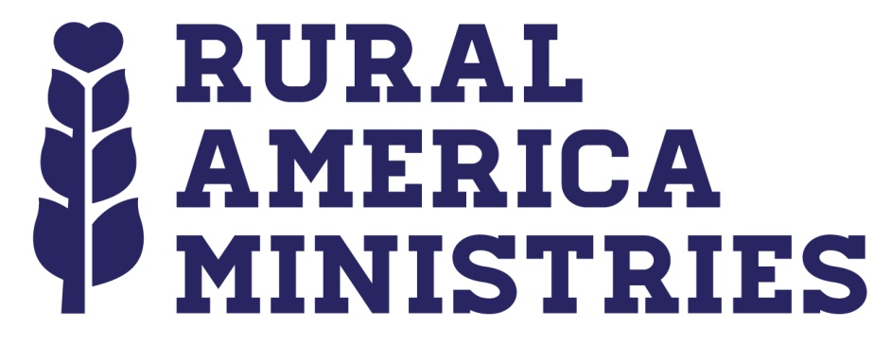

Rural America Ministries
Annual Board Meeting
November 13th – 14th, 2015
Staybridge Suites
4411 SW 15th, Oklahoma City, OK 73108
Agenda

Friday, November 13th, 2015
6:00p – Check-in

6:30p – Dinner

8:00p
- Call to order – Keith Hubbard - President
- Roll call – Maria Lambert – Secretary
- Voting for Board of Directors, Officers and others items as determined

Saturday, November 14th, 2015
8:00a – Prayer & Breakfast

9:00a – noon
- 2015 Year in Review – Jim Weaver – Director
- Vision 2016

Noon – Lunch

1p- 5:00p
- Financials
- Prayer
- Adjournment

